Steganography Analysis and Hidden Data Detection using StegExpose
EXPERIMENT NO: 08
DATE:
1. AIM
To conduct a comprehensive steganalysis lifecycle on digital image evidence using the StegExpose command-line utility; to evaluate Least Significant Bit (LSB) statistical properties and detection algorithms across a target evidence directory; to compute quantitative suspicion scores based on configurable thresholds; and to automatically compile, format, and export the analytical findings into a structured CSV report for forensic documentation.

2. SOFTWARE / TOOLS REQUIRED
- Operating System: Windows, Linux, or macOS
- Runtime Environment: Java Runtime Environment (JRE)
- Forensics Tool: StegExpose (Java .jar executable)
- Evidence Files: Target image files (e.g., .png, .jpg, .bmp)

3. DESCRIPTION
StegExpose is a specialized steganalysis tool designed to detect the presence of hidden data within digital images. Unlike traditional steganography tools used to embed data, StegExpose serves a purely investigative role. It evaluates the statistical properties of an image to identify mathematical anomalies indicative of data hiding techniques, particularly Least Significant Bit (LSB) steganography.
The tool processes images and outputs a quantitative "suspect score" ranging from 0 to 1. By comparing this score against established thresholds, forensic investigators can mathematically estimate the likelihood that an image contains clandestine data, allowing them to triage suspicious files rapidly without needing the original extraction password.

4. PROCEDURE
Step 1: Open Command Prompt as Administrator
- Press the Windows Key, type cmd, right-click on Command Prompt, and select Run as administrator.
Step 2: Navigate to the Working Directory
- Use the change directory (cd) command to point the terminal to your project folder where StegExpose.jar and your evidence directory are located:
- And check is java available.
DOS
cd /d "D:\Digital_Forensics_Lab\Experiment-08-Steganography\StegExpose-master"
java –version
(it shows jre installed or not)
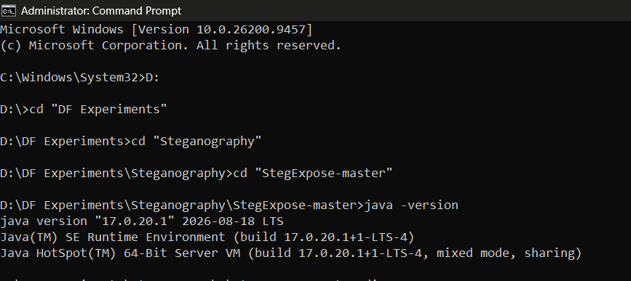
Figure 1: Navigating to the working directory in the Command Prompt
Step 3: Execute StegExpose Analysis with CSV Output
- Run the StegExpose command, passing the path to your evidence folder, the execution speed parameter (default), the statistical threshold (0.2), and the desired output report filename (report.csv):
DOS
java -jar StegExpose.jar "D:\Digital_Forensics_Lab\Experiment-08-Steganography\Evidence" default 0.2 report.csv
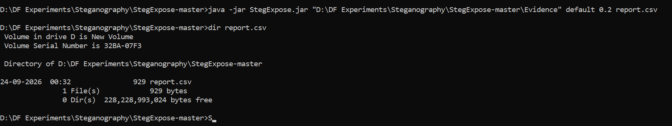
Figure 2: Executing StegExpose via CLI and redirecting output to report.csv
Step 4: Verify and Review the Generated Report
- Once the execution finishes, navigate to your folder or open the file in Microsoft Excel/Notepad to verify the generated report.csv contents.
- Otherwise, directly open the csv file on excel.
DOS
notepad report.csv
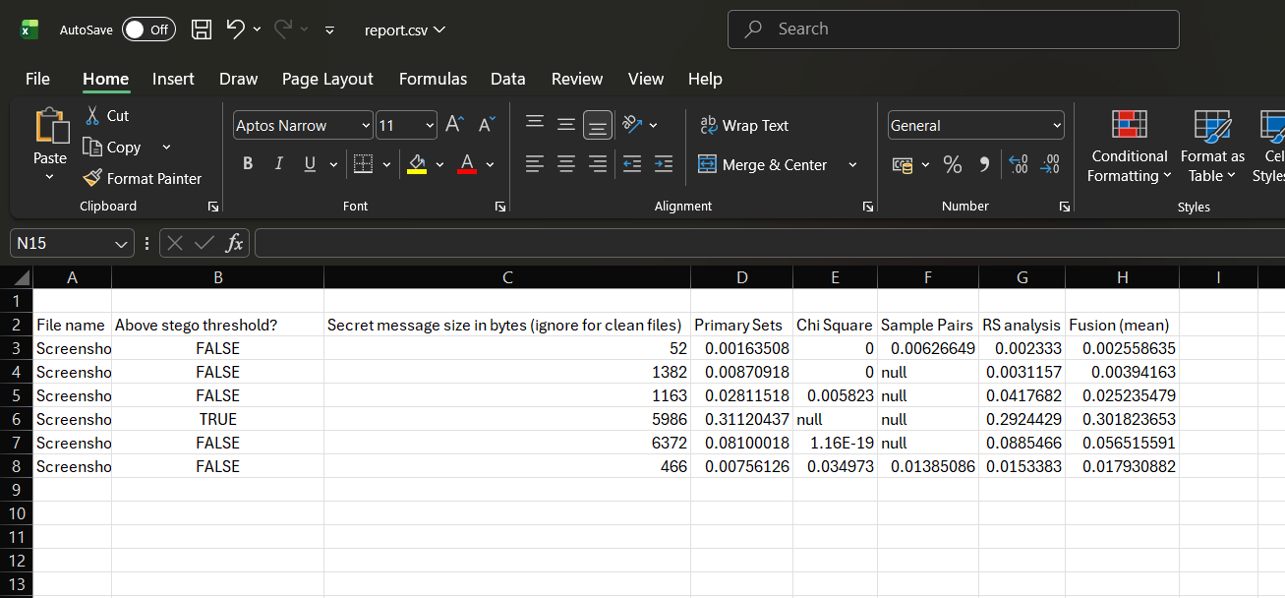
Figure 3: Opening and reviewing the generated CSV report detailing LSB scores and classifications

5. OBSERVATIONS
- Batch Processing: StegExpose scanned all image files within the target evidence folder sequentially.
- Classification Metrics: Each file was assigned an LSB score evaluated against the configured 0.2 threshold. Files exceeding the limit were flagged as suspected steganography carriers.
- Report Compilation: The console results were successfully written to report.csv, containing structured columns for filenames, scores, and status flags.
RUBRICS
Criteria & Marks Assigned | Mark Allotted | Mark Awarded
1. GitHub Activity & Submission Regularity | 3
2. Application of Forensic Tools & Practical Execution | 3
3. Documentation & Reporting | 2
4. Engagement, Problem-Solving & Team Collaboration | 2
Total | 10

6. RESULT
The steganography detection experiment was successfully executed using StegExpose. The tool scanned the evidence directory via the command line, analyzed combinations of LSB metrics, and generated a clean CSV report detailing the cleanliness or suspicion level of each digital image artifact.

